EX NO: 1(a) | SIMPLE INTEREST CALCULATION

AIM:
To Create a simple python program to calculate the simple interest.

ALGORITHM:
- Start
- Input principal amount
- Input rate of interest
- Input time in years
- Calculate interest using si=(p*t*r)/100
- Display the value of si
- Stop
CODE(PYTHON):
# Question 1:
# Write a Python program to calculate and display the interest on a loan amount (Rupees) using
# the formula:
# interest=(principal * rate of interest * time)/100

p=int(input("Enter Principal: "))
r=float(input("Enter Rate of interest: "))
t=int(input("Enter Timer in years: "))
si=float(
(p*t*r)/100
)
print("The interest is ",si)

OUTPUT:
z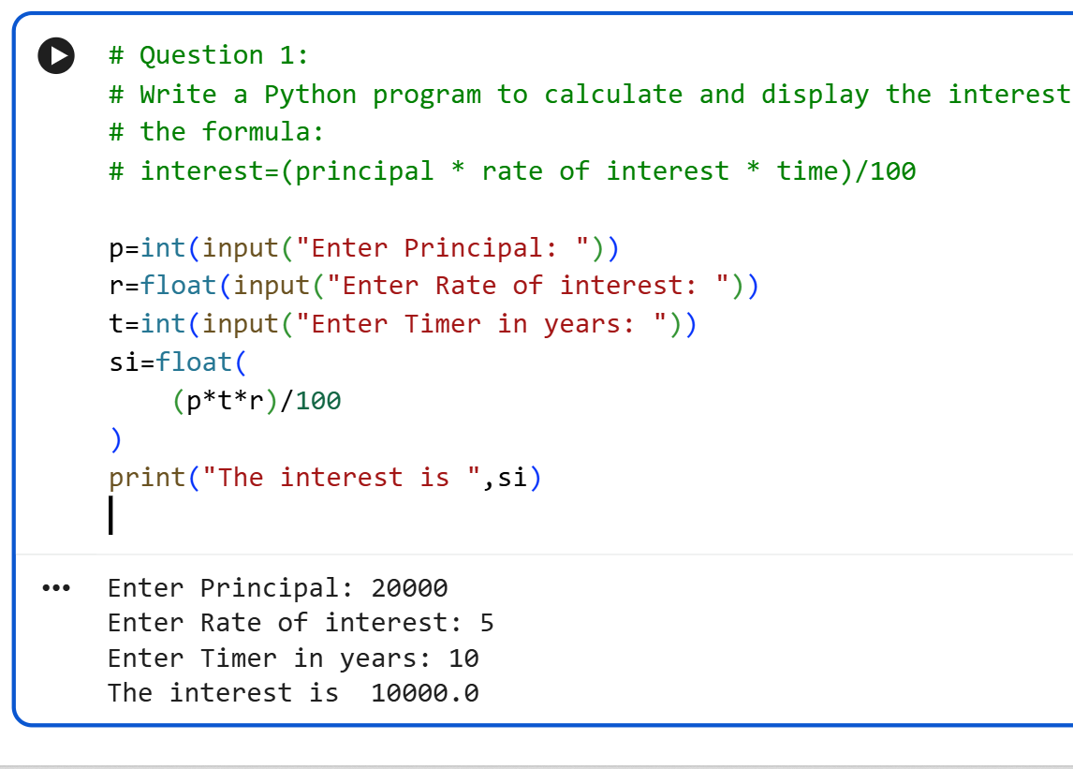
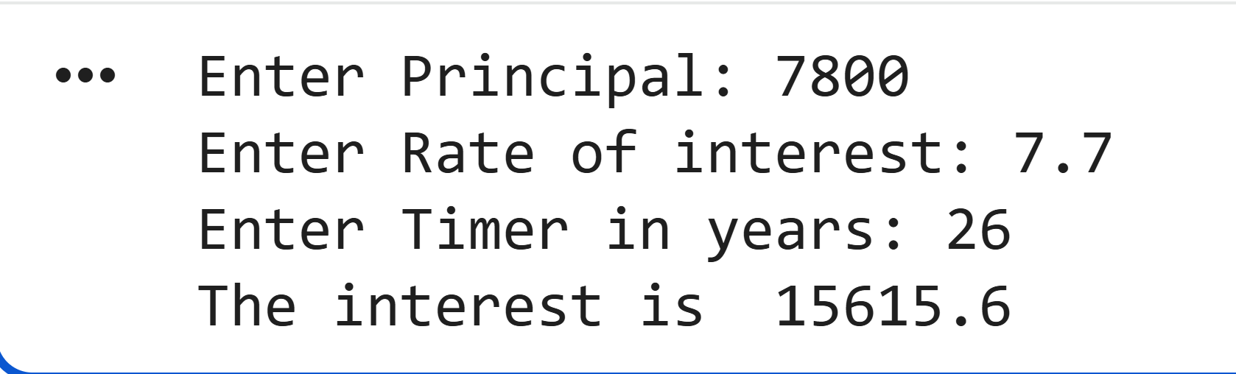

RESULT:
Thus , the python program to calculate the simple interest has been developed succesffully.

EX NO: 1(b) | LEAP YEAR TEST

AIM:
To create a python program to test whether the given year is a leap year or not

ALGORITHM:

- Start
- Input the year
- If the year is divisible by 400:
Display “Leap year”
- Else if the year is divisible by 4 and not divisible by 100:
Display “Leap year”
- Else:
Display “Not a leap year”
- Stop

CODE(PYTHON):
# Question 2:
# Write a python program to find out if a given year is a leap year or not. Any year which is
# divisible by 4 and not by 100 are leap years. Otherwise, any year which is divisible by 400 is
# also a leap year.

year=int(input("Enter the year: "))
if(year % 400==0) or (year %4 ==0 and year % 100 !=0 ):
print("The year ", year,"is a leap year")
else:
print("The year", year,"is not a leap year")

OUTPUT:

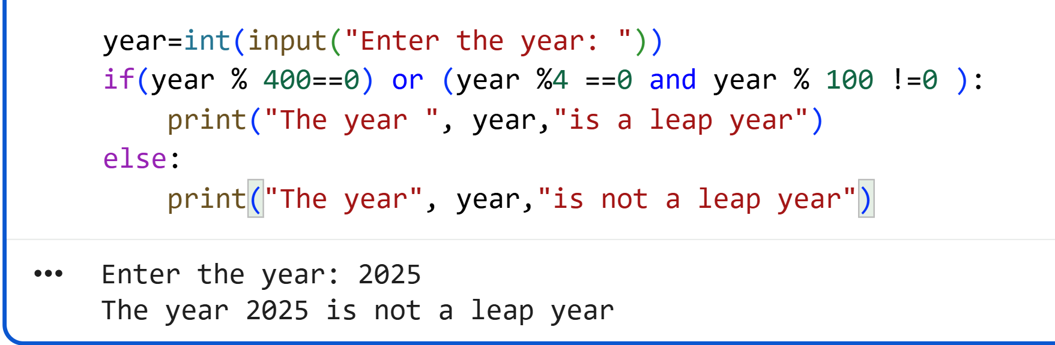

RESULT:
Thus , the python program to test the leap year has been developed succesffully.

EX NO: 1(c) | INVERTED RIGHT ANGLED TRIANGLE PATTERN

AIM:
To print the given pattern using python .

ALGORITHM:

- Start
- Set i = 5
- Repeat while i ≥ 1
- Print i stars in a row
- Decrease i by 1
- Stop

CODE(PYTHON):
# Write a python program to print the given pattern
# *****
# ****
# ***
# **
# *
# and the output is verified.

for i in range(5,0,-1):
print("*" * i)

OUTPUT:

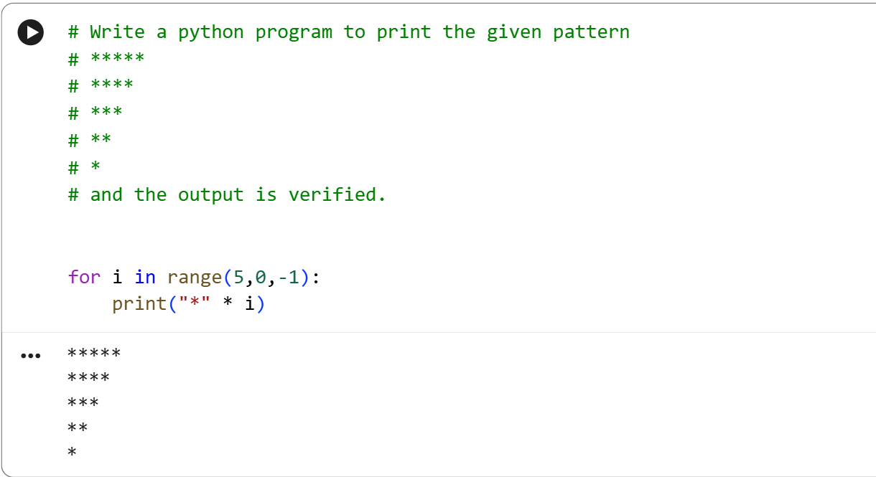

RESULT:
Thus , the given pattern has been printed using python successfully.

EX NO: 1(d) | MENU DRIVEN CALCULATOR

AIM:
To perform basic arithmetic operations using a menu-driven calculator in Python.

ALGORITHM:
- Start
- Input two numbers
- Select operation
- Perform calculation
- Display result
- Stop

CODE(PYTHON):
# Question 4:
# Menu-Driven Calculator
# 1. Addition
# 2. Subtraction
# 3. Multiplication
# 4. Division
first = int(input("Enter first number: "))
second = int(input("Enter second number: "))
choice = int(input("Enter your choice: "))

match choice:
case 1:
print("Result:", first + second)
case 2:
print("Result:", first - second)
case 3:
print("Result:", first * second)
case 4:
print("Result:", first / second)
case _:
print("Invalid Choice")

OUTPUT:

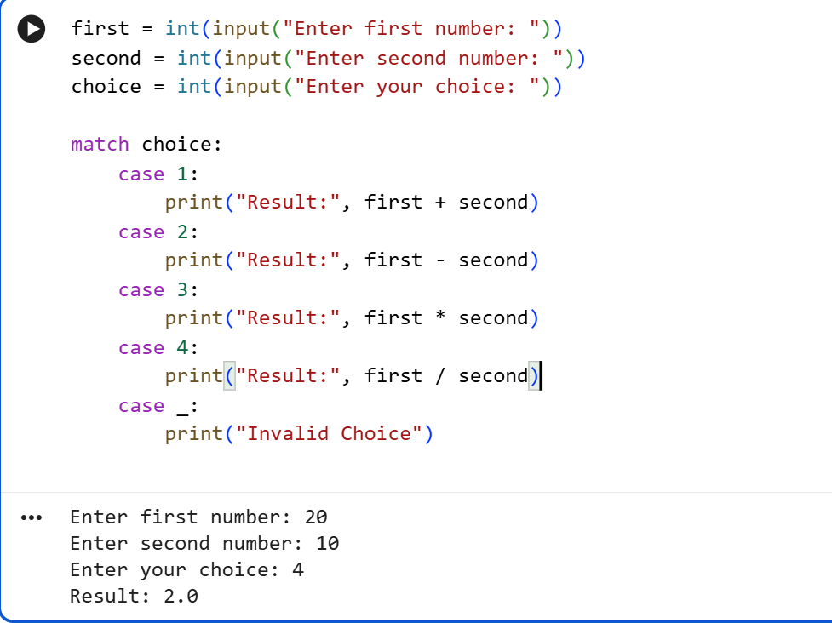

RESULT:
Thus , basic arithmetic operations using a menu-driven calculator in Python has been implemented successfully.

